WELCOME TO CS-521!!!

Tue - Thu, 6-7:30 p.m.

Lecture 11 (Dec 8, 2020)

Week 6:

Homework 6

Quiz 6

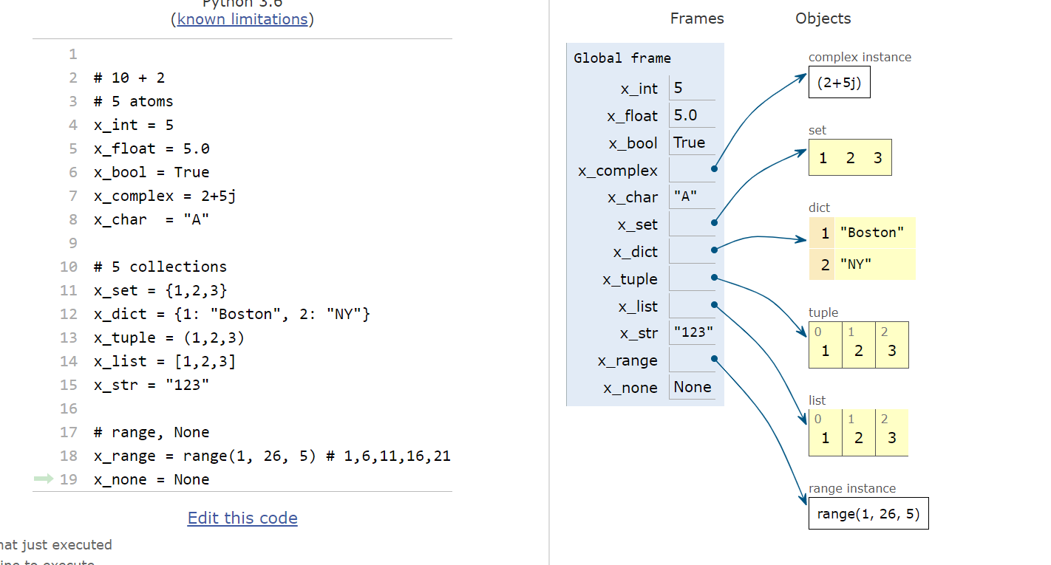

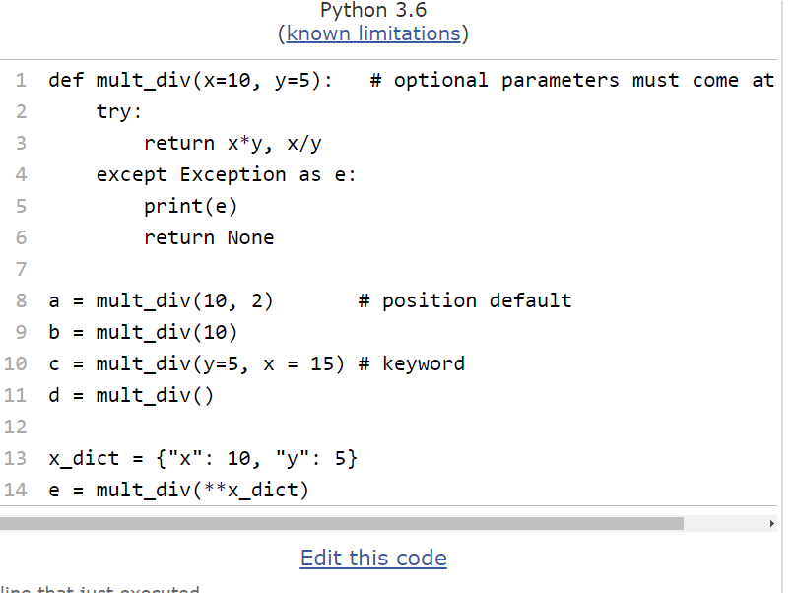

OBJECT-ORIENTED PROGRAMMING

Example: dxefine new “objects” – matrices

(they will contain data plus methods)

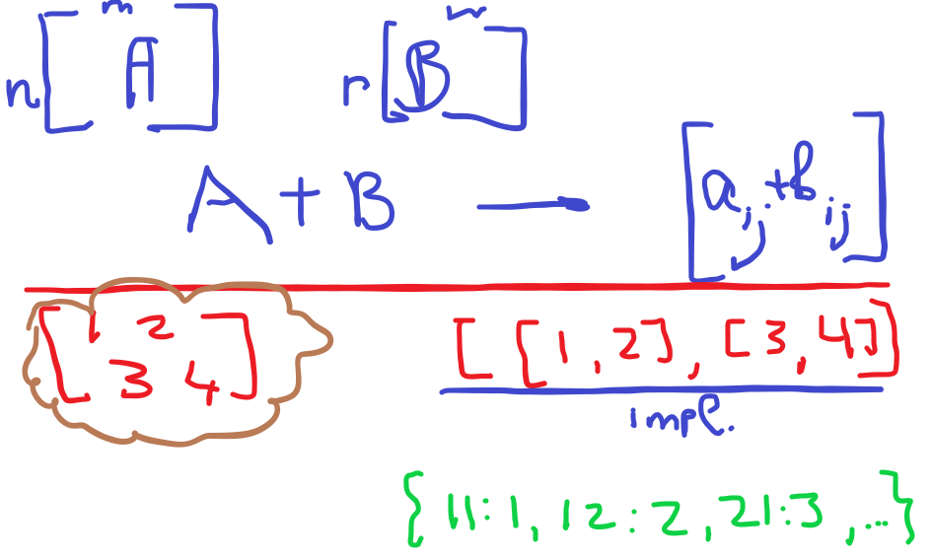

Example 2: strings in Python

x = “Tuesday”

y = x.replace(“d”, “D”)

y will now be “TuesDay”

do we always use empty parenthesis when defining class, like class x() ? Is there any case that we should use class x( a,b,c) ?

class x(a,b,c) in Python means that class x is derived from parent classes a,b and c

(inheritance and Python supports multiple

inheritance, like C++ and unlike Java)

Does self reference a parameter passed into the class? Yes it does, but Python computed self “automatically” when you use a reference label for that intstance

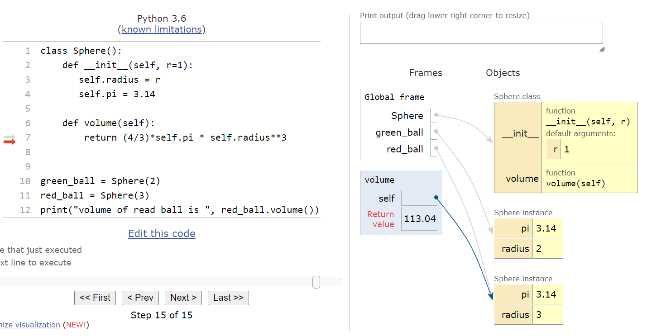

in the above definition, we have multiple copies of the same value “self.pi”

This is inefficient

want: single copy of pi shared across instances

we want to make pi “static”

in Python we define variables after “class” keyword and before __init__()

this makes such variables “static”

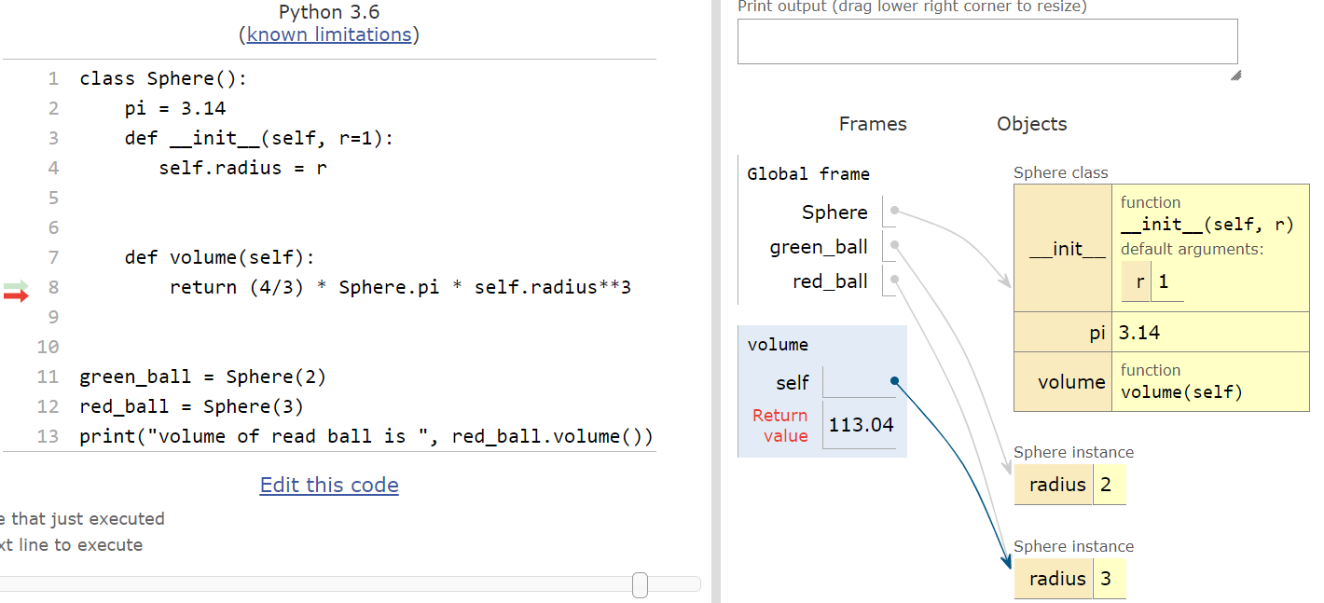

What is the scope of the class in relation to the main body of the Python program?

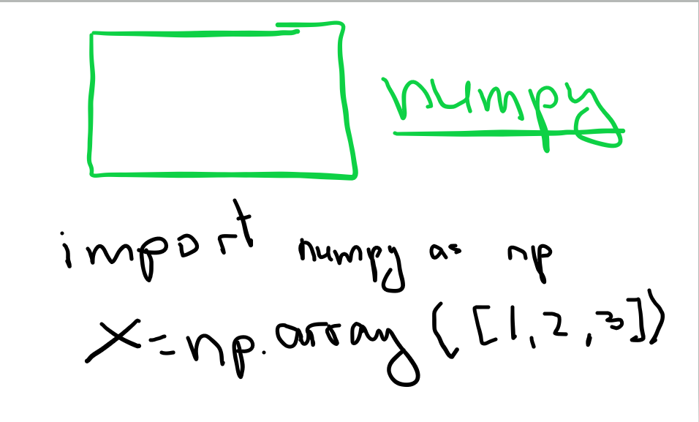

in python, there is a limited mechanism to prevent a user from accessing variables directly

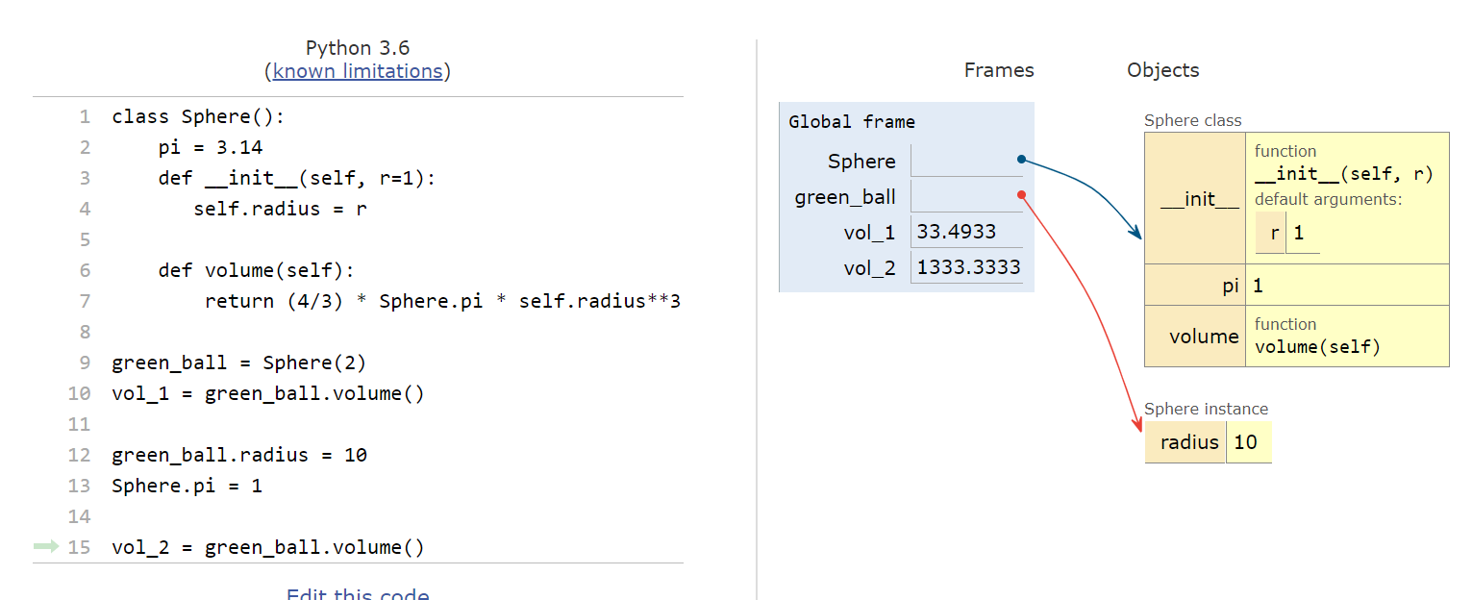

unlike C++ or Java we do not have private or public variables

Python has a limited mechanism: name mangling

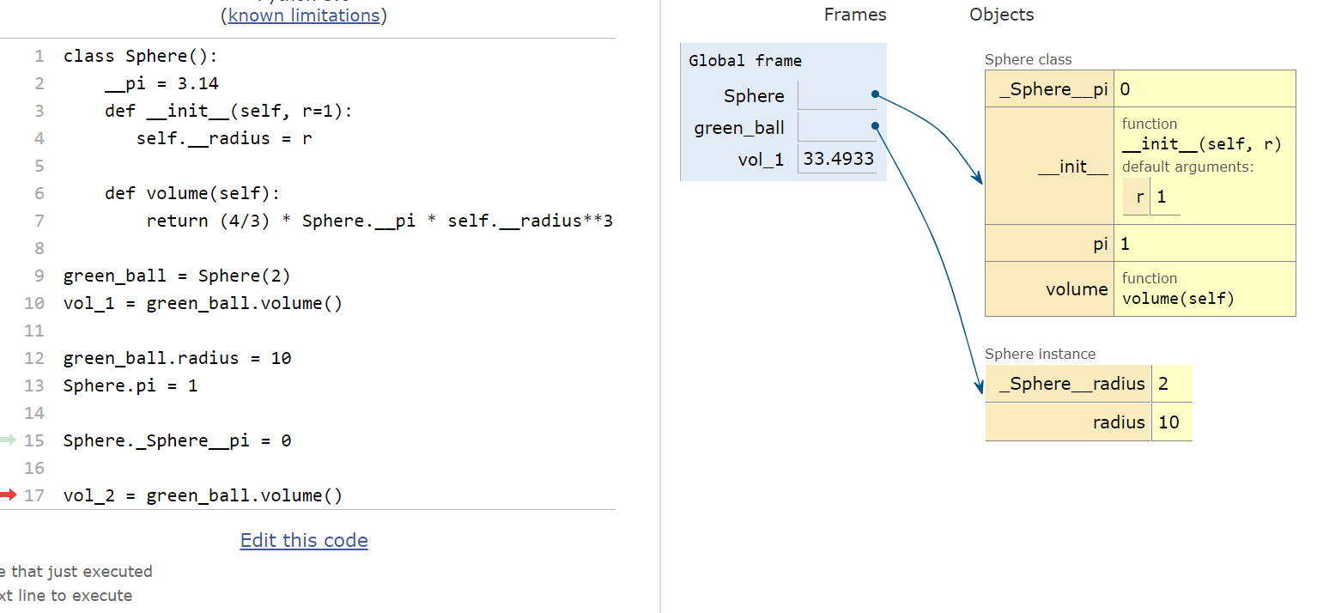

name mangling is not 100% bullet proof method.

You can try to guess variables:

Class._Class__variable

Name mangling is primarily to prevent accidental modification

to describe an object, we define the function __str__()

this will be called by print

* if __str__ is not defined, then Python will call built-in method repr() to print

a “systems message” like

<object at position 0x60987098>

We can define “+”, ‘-“ etc by writing magic functions, like __add__

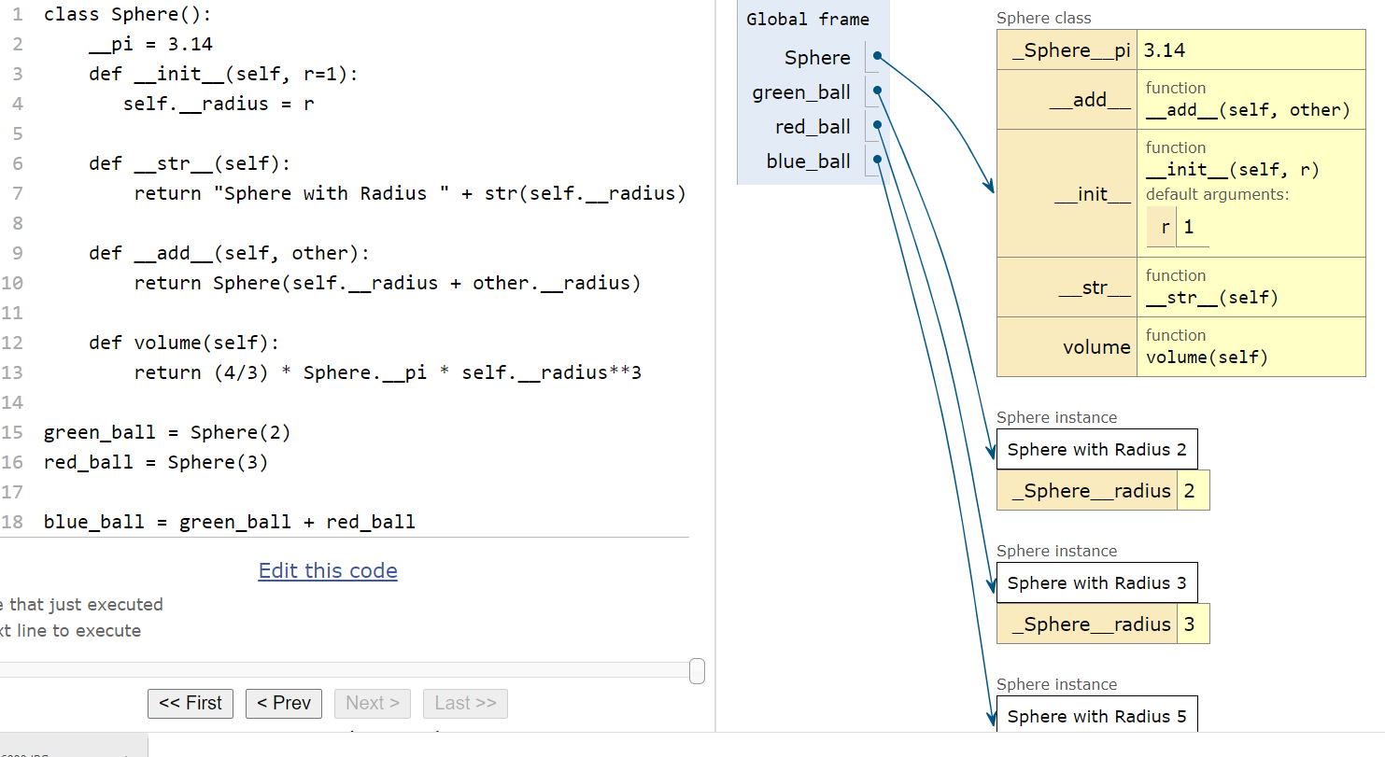

Question: how can I define this:

if red_ball == green_ball:

……..

Answer: define __eq__

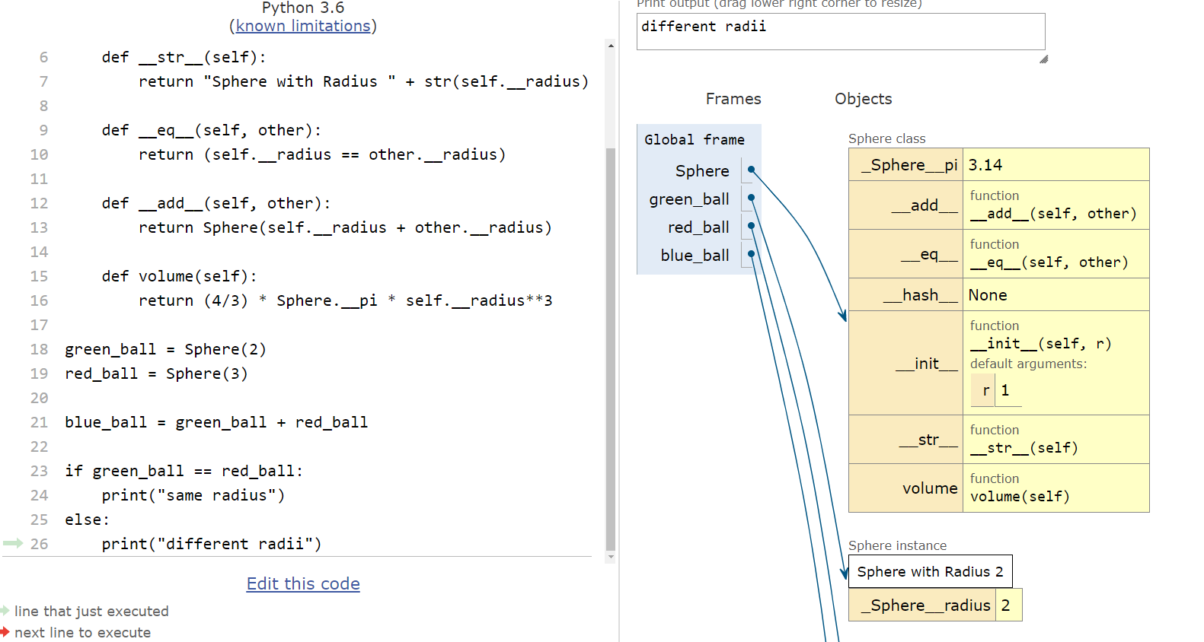

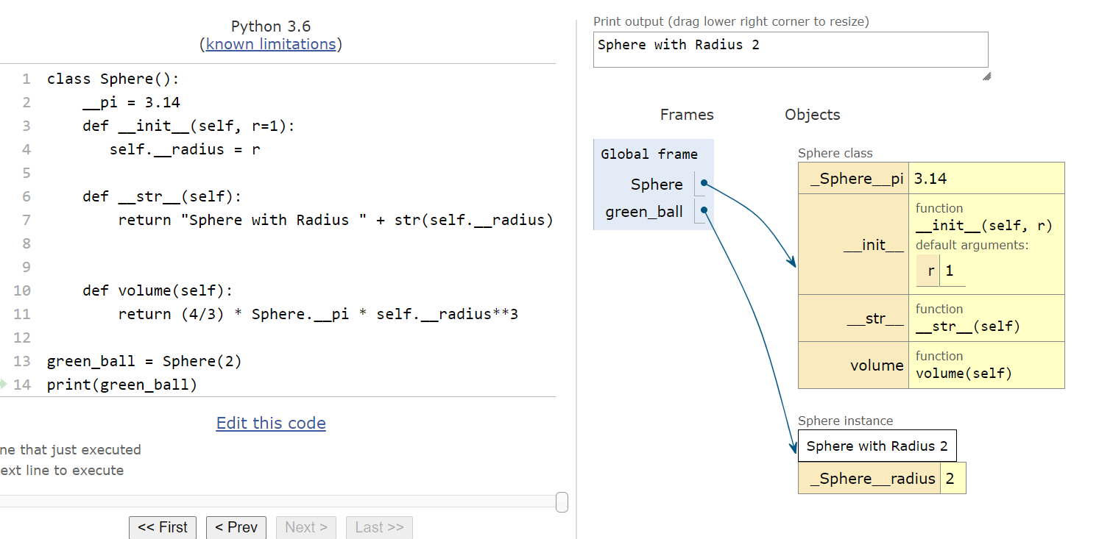

STAY HEALTHY AND WELL!!!!